Network Topology - part 1

Definition: Arrangement of the nodes of a computer network.

Topology = Layout

1. Physical Topology - Placement of various nodes – in physical world
2. Logical topology - Deals with the data flow in the network

Network topology:

1. Bus
   1. All data transmitted between nodes in the network is transmitted over this **common transmission medium** and is able to be **received by all nodes** in the network simultaneously.
   2. A signal containing the address of the intended receiving machine travels from a source machine in **both directions** to all machines connected to the bus until it finds the intended recipient.
   3. 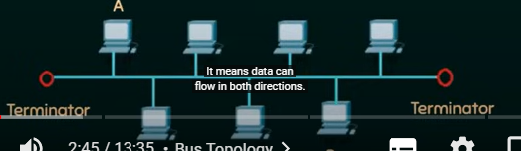
   4. 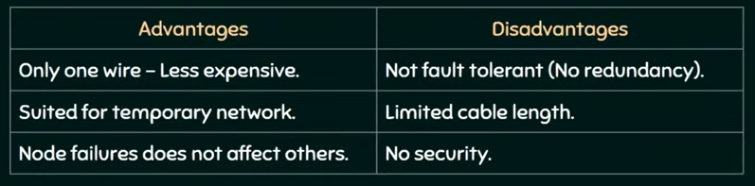
2. Ring
   1. A ring topology is a bus topology in a close loop.
   2. Peer to peer LAN topology.
   3. Two connections: one to each of its nearest neighbors
   4. Unidirectional
   5. Sending and receiving data takes place with the help of a **token**.
   6. 
   7. Whoever has the token, it means it is their turn to send the data.
   8. 
3. Star
   1. Every node is connected to a central node called a hub or switch
   2. Centralized Management
   3. All traffic must pass through the hub or switch.
   4. 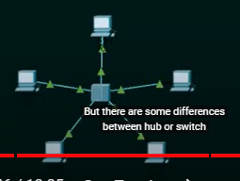
   5. 
   6. 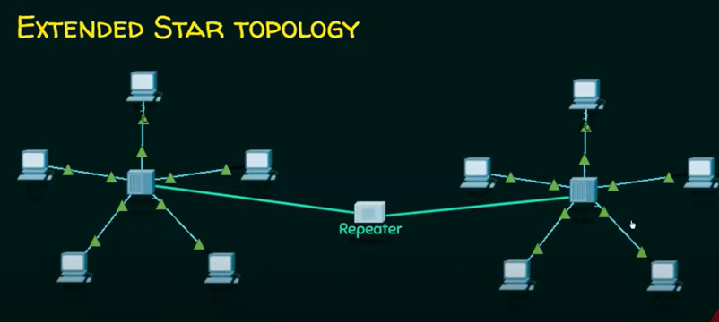
4. Mesh
   1. Each node is directly connected to every other nodes in the network.
   2. Fault tolerant and reliable.
   3. 
   4. 
5. Hybrid
   1. 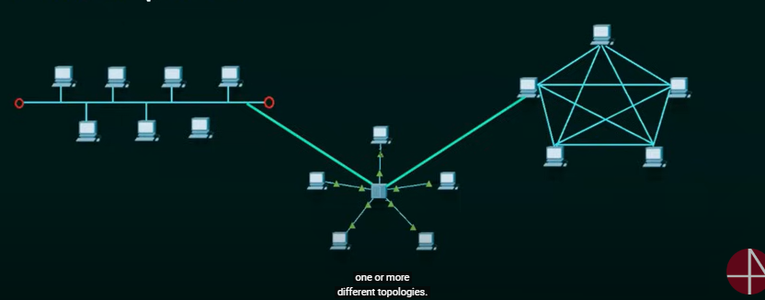
   2. One or more different types of topologies.